DSA0502 – QUERY PROCESSING FOR DATA SCIENCE
LAB PROGRAMS
NAME: B KIRTHANAA REG. NO - 192324244

1.Write a Pandas program to select the distinct Department IDs from an Employees file.
AIM:
To read an employee dataset using Pandas and display the unique Department IDs.
CODE:
import pandas as pd

# Read the dataset
emp = pd.read_csv("Employees.csv")

# Display distinct Department IDs
print("Distinct Department IDs:")
print(emp["DepartmentID"].unique())

OUTPUT:
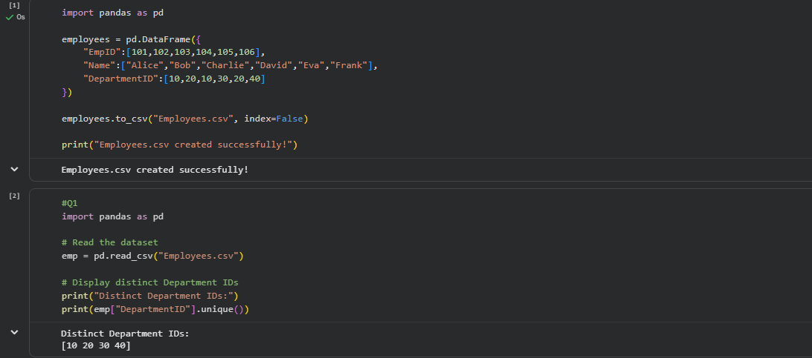

2. Write a Pandas program to display the IDs of employees who have done two or more projects.
AIM:
To read employee project data and display the Employee IDs who have worked on two or more projects.
CODE:
import pandas as pd

# Read dataset
data = pd.read_csv("Projects.csv")

# Count projects for each employee
count = data.groupby("EmpID").size()

# Employees with two or more projects
print("Employees with two or more projects:")
print(count[count >= 2].index.tolist())

OUTPUT:
